Homework 3a – Working with ArrrayLists
Student Name: Andrew Steele
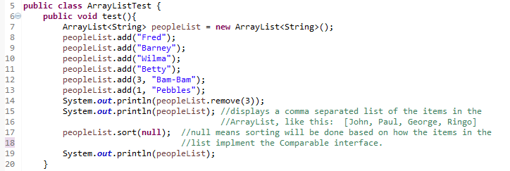
Figure 1
Consider the code shown in Figure 1 and answer the following questions:
- (2 points) What will be printed out in line 14?
Wilma
- (2 points) What will be printed out in line 15?
[Fred, Pebbles, Barney, Bam-Bam, Betty]
- (2 points) What will be printed out in line 19?
[Bam-Bam, Barney, Betty, Fred, Pebbles]
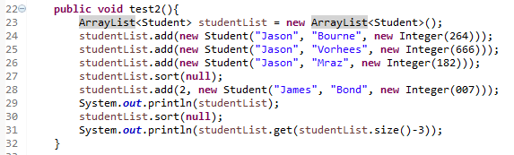Figure 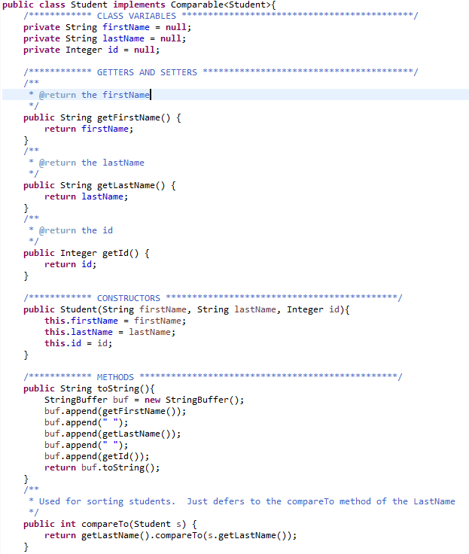
Figure 2

Consider the Student class shown in Figure 2 and the code shown in Figure and answer the following questions:
- (2 points) What will be printed out in line 29?
[Jason Bourne 264, Jason Mraz 182, James Bond 7, Jason Vorhees 667]
- (2 points) What will be printed out in line 31?
Jason Bourne 264

BONUS QUESTION (2 points)
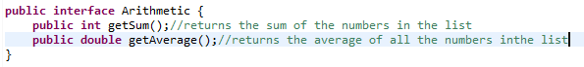
Figure 3
- Create a class that provides all of the functionality of an ArrayList, but that also implements the interface shown in Figure 3. Include a main method in your class that will test out this functionality (i.e., add 4 or 5 numbers to the list and then run each of the functions described by the interface). This class should ONLY be able to hold a list of Integers. Just copy-an-paste your solution (i.e. your code) below.

/**
* Write a description of class HomemadeList here.
*
* @author (your name)
* @version (a version number or a date)
*/

import java.util.Scanner;
import java.lang.StringBuffer;
import java.lang.String;

public class HomemadeList implements Arithmetic
{
public int index;
public int size;
public int[] array;
public Scanner input = new Scanner(System.in);
public HomemadeList(int size)
{
this.size = size;
this.array = new int[size];
for (index = 0; index < size; index++)
{
System.out.println("Please enter whole number " + index + ": ");
array[index] = input.nextInt();
}
}

@Override
public int getSum()
{
int total = 0;
index = 0;
while(index < size)
{
total += array[index];
index++;
}
return total;
}

@Override
public double getAverage()
{
int avg = 0;
index = 0;
while(index < size)
{
avg += array[index];
index++;
}
avg = avg/size;
return avg;
}

public void add(int addIndex, int element)
{
size++;
int newArray[] = new int[size+1];
for (int i = 0; i < addIndex; i++)
{
newArray[i] = this.array[i];
}
newArray[addIndex] = element;
for (int i = addIndex+1; i < size; i++)
{
newArray[i] = this.array[i-1];
}
this.array = newArray;
}

public void remove(int removeIndex)
{
size--;
int newArray[] = new int[size];
for (int i = 0; i < removeIndex; i++)
{
newArray[i] = this.array[i];
}
for (int i = removeIndex; i < size; i++)
{
newArray[i] = this.array[i+1];
}
this.array = newArray;
}

public String toString()
{
StringBuffer output = new StringBuffer();
output.append("[");
for(int i = 0; i < size; i++)
{
output.append(array[i]);
}
output.append("]");
return output.toString();
}

public static void main(String[] args)
{
HomemadeList h1 = new HomemadeList(4);
HomemadeList h2 = new HomemadeList(5);

System.out.println("First Sum: " + h1.getSum());
System.out.println("First Average: " + h1.getAverage());

h1.add(1, 5);
System.out.println(h1.toString());

System.out.println("Second Sum: " + h2.getSum());
System.out.println("Second Average: " + h2.getAverage());

h2.remove(3);
System.out.println(h2.toString());
}
}

